Dry SUmp Pump Bubble Elimination for hydraulic hybrid vehicle systems

By

Jason Moore

A Thesis Submitted to the Faculty of the

DEPARTMENT OF MECHANICAL ENGINEERING

In Partial Fulfillment of the Requirements
For the Degree of

MASTER OF SCIENCE

In the Department of Mechanical Engineering
THE UNIVERSITY OF MICHIGAN

2 0 0 7

Committee Members:

Albert Shih Professor, ME

Zoran Filipi, Research Associate Professor, ME
Acknowledgements
First I would like to thank my faculty advisors, Professor Albert Shih and Professor Zoran Filipi for there supervision and support. I would also like to thank the Environmental Protection Agency by which this project was funded and especially Neil Johnson, Andy Moskalik, and Tony Tesoriero for their guidance and insight from the EPA on this project. I also thank David Swain for working with me on my hydraulic bicycle project and first sparking my interest in hydraulic technology. I also thank my parents, John and Beth Moore, for their support and encouragement.
Table of Contents
List of Figures i
List of Tables i
Biography ii
Abstract iii
Chapter 1. Introduction 1
1.1 Literature Review of Hydraulic Fluid Bubble Elimination 3
1.2 Efficiency Testing of Deaeration Devices Literature Review 4
1.3 Goals and Objectives 6
1.4 Overview of Thesis 6
Chapter 2. Bubble Elimination Efficiency Testing Apparatus 8
2.1 Overview 8
2.1.1 Description of fluid flow diagram 9
2.1.2 Closed loop system 11
2.1.3 Necessity of second dump tank 12
2.1.4 Check valves 12
2.1.5 Clear tubes 12
2.1.6 Drip tank 12
2.2 BEETA Component Design and Selection 13
2.2.1 Mixing air and hydraulic fluid 13
2.2.2 Graduated cylinder 13
2.2.3 Hydraulic fluid tanks 15
2.2.4 Pressure gauges 15
2.2.5 Mass flow meter 15
2.2.6 Borrowed items and petty cash items 16
2.3 Fabrication 16
2.3.1 Bracketry items 17
2.3.2 Routing hydraulic lines 18
2.4 Electrical Setup and Data Acquisition 18
2.4.1 Wiring schematic 18
2.4.2 Data acquisition 19
2.5 Procedure for Use 20
Step 1: Presetting all the valves 20
Step 2: Start air flow 21
Step 3: Start hydraulic fluid flow 21
Step 4: Back pressure 21
Step 5: Begin test 21
Step 6: Stopping the hydraulic fluid flow 21
Step 7: Final measurements and draining the system 22
Chapter 3. Performance Efficiency and Testing Results 23
3.1 Bubble Removal Efficiency 23
3.2 Experimental Procedure 24
3.3 Results -- Effect of Flow Rate 25
3.4 Results -- Effect of Vent Pressure 27
3.5 Comparison with Suzuki et al. [15] Testing Results 28

3.6 Conclusions from Testing 30
Chapter 4. Theory of Dissolving Gas and Forces on Bubbles 31
4.1 Henry’s Law for Dissolved Gas 31
4.1.1 Cyclone pressure effect on dissolved gas 32
4.2 Forces Acting on Air Bubble 32
4.2.1 Drag 32
4.2.2 Buoyancy 33
4.2.3 Centrifugal force 34
4.3 Bubbles Naturally Settling out of Fluid 34
4.3.1 Dependence on bubble size 34
4.3.2 Dependence on pressure above fluid 35
4.3.3 Dependence on temperature 36
4.4 Conclusions from Theory 38
Chapter 5. Conclusions and Recommendations 39
Appendix A: Survey Deaeration devices 41
Appendix B: Sizing of Graduated Cylinder 52
Appendix C: Bill of Materials 53
Appendix D: Petty Cash Spent 55
Appendix E: Items Borrowed from EPA 56
Appendix F: Matlab Program for Data Collection Analysis 58
Appendix G: Vacuum System for Dry Sump Pump 63
Resources 64

List of Figures

Figure 1.1 Dry sump pump fluid diagram 3
Figure 2.1 Overview of bubble elimination efficiency testing apparatus (BEETA) 9
Figure 2.2 Fluid diagram for the BEETA system 10
Figure 2.3 Koflo static mixer 13
Figure 2.4 Screen mixer inside clear tube 13
Figure 2.5 Graduated cylinder full of hydraulic fluid 14
Figure 2.6 Minimum and maximum flow meter range 16
Figure 2.7 Lower shelf 17
Figure 2.8 Valve bracket 17
Figure 2.9 Fluid lines routed underneath BEETA system table 18
Figure 2.10 Electrical wiring diagram 19
Figure 2.11 User interface for data acquisition 20
Figure 3.1 Cyclone bubble elimination performance 26
Figure 3.2 Increasing P_{delta} effect on low flow rates 27
Figure 3.3 Lack of efficiency to varying P_{delta} 28
Figure 3.4 Suzuki et al. testing results [15] 29
Figure 3.5 Suzuki et al. testing results reorganized [15] 30
Figure 4.1 Buoyancy force on bubble 33
Figure 4.2 Rise velocities strong dependence on bubble radius 35
Figure 4.3 Low pressure bubble rise velocity effect 36
Figure 4.4 Temperature bubble rise velocity effect 38

List of Tables
Table 1: Starting Valve Configuration 20
Table 2: Low Flow Rate Testing 24
Table 3: High Flow Rate Testing 25
Table 4: Constants of Solubility in Hydrocarbon Fluid [28] 32

Biography

Jason Moore was born in Marion, Indiana in 1984. He is the son of John and Beth Moore. In 2002 he enrolled at the University of Michigan and completed his bachelor’s degree in mechanical engineering and received a minor in math after four years of school. Jason spent the last year pursuing a Masters degree in mechanical engineering under the guidance of Professor Albert Shih and Professor Zoran Filipi. Jason plans to continue his education and pursue a PhD in mechanical engineering at the University of Michigan.

Abstract
The goal of this research is to investigate bubble elimination via cyclone bubble eliminator for use in a dry sump pump system, for the specific application of hydraulic hybrid vehicles. Air bubbles in a hydraulic system cause poorer efficiencies, pump cavitation, oil deterioration, noise generation, and oil temperature rise. For hydraulic hybrid vehicle systems, dry sump pumps are more efficient than wet sump pumps but have the aeration issues because of the air on the opposite side of the pistons. The fluid leaks to the air and will eventually need to be deaerated and returned to the system.

This research investigates the mechanical cyclone system for deaeration. A bubble elimination efficiency testing apparatus (BEETA) was built to measure the efficiency of the cyclone bubble elimination device. The BEETA system measures the amount of air in the fluid air mixture going into the bubble eliminator and then measures the quantity of air in the fluid mixture exiting the bubble eliminator, therefore allowing the determination of the bubble eliminator efficiency. Testing results reveal that the cyclone device removes less than 95% of small bubbles (< 0.75 mm radius), which is unacceptable for a dry sump pump application. A model was developed to explain the effects of pressure, temperature, and bubble radius on a bubble in hydraulic oil.

Chapter 1. Introduction

Hybrid vehicles use a mixture of power sources to be more energy efficient and environmentally friendlier than conventional automotive drive systems [,]. Two types of hybrid technology are the electric hybrid and hydraulic hybrid. Electric hybrid vehicles connect a generator to the engine and a battery system stores energy from the generator. In a parallel electric hybrid, the engine and an electric motor drive the wheels. In a series electric hybrid, the battery system powers electric motors that drive the wheels.

Hydraulic hybrid vehicles connect a hydraulic pump to the engine that then stores energy in accumulators. In a parallel hydraulic hybrid a hydraulic motor retrieves energy from the accumulators and assists the engine in powering the wheels. This system uses fewer components than a series system and therefore is ideal for smaller vehicles. In a series hydraulic hybrid a hydraulic motor completely powers the wheels. Series systems are more energy efficient than parallel and due to hydraulics ability to transfer high power this system is ideal for heavy vehicles. The engine in hybrid vehicles can run at an optimum speed range for better efficiency and lower emissions [Error: Reference source not found]. Regenerative breaking can be implemented to recover energy normally lost in braking [].

Electric hybrids are currently being successfully manufactured and sold to consumers. The electric hybrids obtain better gas mileage than conventional drive systems in city driving. However, for large vehicles, the electric hybrids lack the efficiency at high power and cost more []. Hydraulic hybrid systems offer better efficiency for heavy vehicles and are more efficient at regenerative breaking than electric hybrid vehicles [,,]. However, hydraulic hybrid vehicles have yet to be manufactured for general consumers because of a lack of technology and packaging problems []. Packaging is a serious challenge because many of the hydraulic components, especially the accumulators, are fairly large and cannot easily fit into existing vehicle dimensions.

Hydraulic hybrid propulsion systems can either use dry or wet sump pumps. Dry sump pumps contain a series of pistons to allow for variable displacement pumping where hydraulic fluid is on one side of the piston (fluid being pumped) and air on the opposing side of the piston. In wet sump pumps both sides contain hydraulic fluid – one side is high pressure fluid being pumped and the other is stationary low-pressure fluid. Dry sump pumps are more efficient than wet sump pumps because the air is less viscous than the hydraulic fluid and therefore offers less resistance. Recent testing at the US Environmental Protection Agency (EPA) shows 2.5% efficiency improvement of a dry sump pump over a wet sump pump when running at 3000 rpm and 13.8 MPa []. The downfall in using dry sump pumps in hydraulic hybrid vehicles is that hydraulic fluid will leak around the piston into the air side of the pump and become aerated (bubbles and dissolved gas) [Error: Reference source not found]. The aerated hydraulic fluid is then returned to the main line of the hydraulic system and can cause damage. Bubbles in hydraulic fluid cause poorer efficiencies, pump cavitations, oil deterioration, noise generation, and oil temperature rise [,]. Dissolved gas is not as dangerous to the system components; however, the dissolved gas can easily form into bubbles from pressure changes in the system []. The aerated oil will need to be deaerated. The dry sump pump hydraulic system with deaeration is illustrated in Figure 1.1. The red lines indicate aerated fluid. The black lines illustrate deaerated fluid which is able to be used in the main line of the system. The deaeration system for a dry sump pump is the focus of this paper.

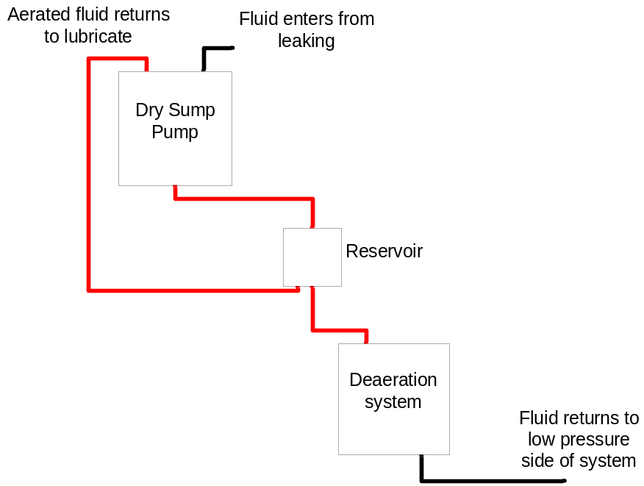
Deaerated oil
Aerated oil
Figure 1.1 Dry sump pump fluid diagram

1.1 Literature Review of Hydraulic Fluid Bubble Elimination
There are several ways to remove air bubbles from fluid that have been studied in literature. However, this subject has not been extensively studied because in traditional hydraulic systems deaeration can take place naturally in a large open to atmosphere tank by allowing amble-settling time [Error: Reference source not found]. This technique cannot work in a hydraulic hybrid vehicle because it must occupy a small volume (packaging concerns) and be lightweight.

One deaeration system that is currently being used is cyclone bubble elimination devices that rotate the oil-air mixture, which cause the air to separate from the fluid and then be pulled out [,]. Suzuki et al. [,] has studied the concept of a cyclone bubble elimination systems and outlined the theory behind and proof of non-quantitative performance. It has been stated that cyclone bubble eliminators have difficulty removing small bubbles in viscous fluid []; however, no quantitative bubble removal performance was found.

The use of a gas permeable oil impermeable membrane is an option for deaeration. Gas can be pulled out of the fluid by creating a pressure difference across the membrane. Membrane systems for micro-gravity conditions (where buoyancy will not allow bubbles to naturally settle out) have been developed and studied [,]. Membrane devices are also used in water and chemical purification processes to remove dissolved gas but not commonly used in degassing of hydraulic oil []. Large membrane surface area is required for the device to work which can make the device bulky thereby making it non-ideal for hydraulic hybrid vehicles [].

Zeolite is a crystal that can trap and redirect unwanted molecules and much research has gone into these crystals [,]. Currently it is used in industry in a wide variety of applications; however, it has not yet been experimented in degassing of hydraulic oil [Error: Reference source not found]. Therefore, the feasibility of this concept is unknown and extensive research would need to be performed by chemical engineering researchers to determine its effectiveness.

A survey of bubble elimination methods has been conducted. Results of the survey are summarized in Appendix A. Based on the survey, the cyclone technology was selected due to its compact size and promising theory research [Error: Reference source not found,Error: Reference source not found]. The option of designing a cyclone bubble elimination device was explored and conclusion was made along with key EPA collaborators not to pursue this option because of it was a complex engineering task. A GE-Totten BM-6 cyclone bubble eliminator was selected for evaluation of hydraulic fluid deaeration.

1.2 Efficiency Testing of Deaeration Devices Literature Review
Accurately determining the bubble elimination efficiency of deaeration devices is necessary to decide if a given deaeration device is acceptable to be used in a dry sump pump system. To determine the bubble elimination efficiency of a device the amount of gas in the hydraulic fluid exiting the device must be measured. The measurement device must be able to measure small quantities of gas in fluid and be very accurate. This task has been accomplished by several methods in literature.

A void meter can measure the quantity of gas in a fluid and was used for experiments conducted by Suzuki et al. [Error: Reference source not found,Error: Reference source not found] and Morgan et al. []. The void meter works by combining a coriolis mass flow meter with a volumetric flow meter. With these two values the density flow rate can be calculated which can then yield the percentage of air in fluid []. However, the void meter cannot accurately measure small bubble percentages and dissolved gas [Error: Reference source not found]. For testing a high level of accuracy is required for determining the bubble elimination efficiency. Therefore, this is not a feasible option.

An optical probe can be used to measure the quantity of gas in a liquid. This works by a probe being positioned inside the fluid and emitting light and then measuring the intensity of the light reflected back. However, this option is not very accurate because air bubbles can directly strike the probe, which causes variations in the reading depending on the bubble velocity, and how wet the probe is after the bubble strikes [].

Indirect measurement via two air mass flow meters can determine the amount of air inside the hydraulic oil. This system uses an air mass flow meter to measure incoming air and another air mass flow meter to measure outgoing air from the bubble elimination device. The difference in airflow then equals the amount of air in the oil by the law of conservation of mass. Air mass flow meters are common devices used in testing but no literature was found which uses this particular system. The accuracy of this system is dependent on the accuracy of the mass flow meters, which generally lack low flow accuracy []. Therefore, this system is not ideal for determining bubble elimination efficiency.

Volume measurements (via graduated cylinder) before and after air settles out of fluid can be used to determine the percentage of gas in fluid. This technique is mentioned throughout literature [Error: Reference source not found,Error: Reference source not found]. This method offers between 97.93% and 99.99% volumetric percentage of hydraulic fluid when using the graduated cylinder sizing given in Appendix B.

Based on the review of testing methods the graduated cylinder method was chosen because of its ability to read high volumetric percentages of hydraulic fluid and its high accuracy. This system was utilized to determine bubble removal efficiency of cyclone bubble elimination.

1.3 Goals and Objectives
The goals of this research are:

- Develop a system to measure bubble elimination
- Determine bubble removal efficiency in a cyclone device
- Understand forces that act on bubbles and dissolving process
- Model how bubble size, pressure, and temperature effect bubble removal

All of these goals lead to the overall objective of designing and developing a dry sump pump deaeration system for use in a hydraulic vehicle.

1.4 Overview of Thesis
This thesis contains five chapters which describe the work that has been completed on the dry sump pump bubble elimination for hydraulic hybrid vehicle systems project.

Chapter 2 Bubble Elimination Efficiency Testing Apparatus: BEETA was constructed and allows for experimental testing and optimization of any style of in-line bubble eliminator. This versatility makes it a great asset to the project.

Chapter 3 Performance Efficiency and Testing Results: The efficiency of a cyclone bubble elimination device was tested under varying conditions. The device failed to remove an adequate amount of small bubbles and dissolved gas.

Chapter 4 Theory of Dissolving Gas and Forces on Bubbles: The process of dissolving gas into fluid is researched. Also the forces on bubbles in fluid are examined along with the effects that bubble radius, pressure, and temperature have on bubbles settling out of fluid.

Chapter 5 Conclusions and Recommendations: From testing it is concluded that the cyclone device cannot be used in a dry sump pump. Based on this conclusion and theory studied it is recommended that settling methods that involve pressure and temperature be further researched along with the use of alternative gases in the dry sump pump.

Chapter 2. Bubble Elimination Efficiency Testing Apparatus

To allow for testing of any style of inline bubble elimination device the BEETA system was developed. The chapter gives the overview of the BEETA system, discusses design and component selection, describes fabrication, evaluates electrical setup and data acquisition, and contains the procedure for using the BEETA system.

2.1 Overview
The BEETA system, shown in Figure 2.1 allows for the efficiency testing and pressure and flow optimization of any style of bubble elimination device. This task is accomplished by first creating a known quantity of hydraulic fluid to air mixture. This mixture is then sent to the bubble elimination device of choice. The mixture that exits the bubble eliminator is then measured to determine the quantity of air inside the hydraulic fluid. The efficiency of the bubble eliminator can then be calculated based on this information. To allow for optimization controls exist to regulate inlet flow rate and pressure, air vent flow rate and pressure, and outgoing pressure. This section gives an overview of the BEETA design.
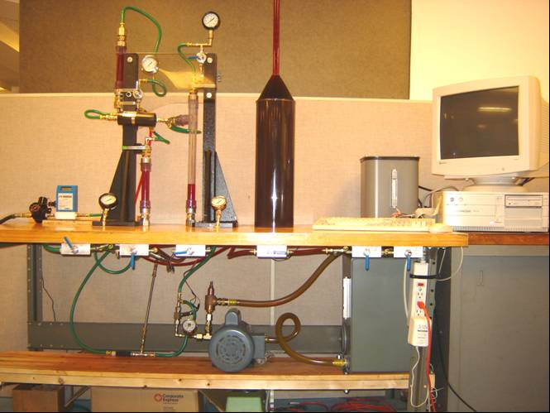
Graduated Cylinder
Air Mass Flow Meter
Air Pressure Regulator
Dump Tank
Static Mixer
Hydraulic Pump and Motor
Fluid Tank
Bubble Eliminator
Drip Tank
V1
V9
V7
V2
V5
V6
V4
V3
V8
Computer with Data Acquisition
Figure 2.1 Overview of bubble elimination efficiency testing apparatus (BEETA)

2.1.1 Description of fluid flow diagram
The fluid flow diagram for the BEETA system is shown in Figure 2.2. For easy referencing the valves are numbered V1 through V9 and will be referred to in this manner throughout the paper.

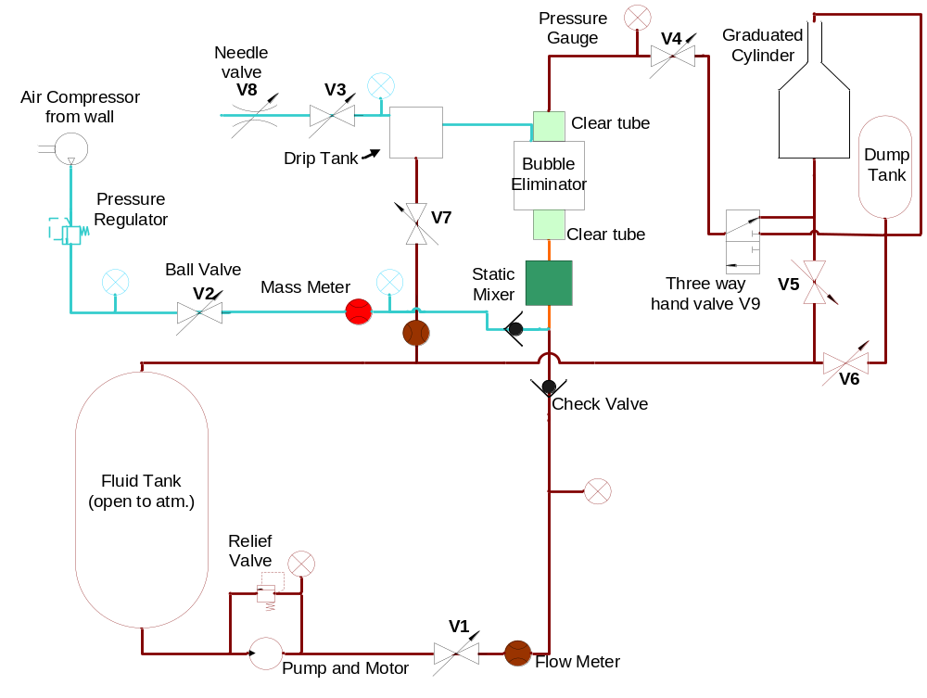
Hydraulic oil lines
Air lines
Mixture of air and hydraulic oil

Valve Number | Purpose
V1 | With relief valve regulates oil flow and pressure
V2 | Regulates air flow rate
V3 | Controls bubble eliminator vent pressure
V4 | Controls back pressure on the outlet flow of the bubble eliminator
V5, V6, V7 | Allows oil to dump back into fluid tank
V8 | Fine tune adjustment of air vent flow rate
V9 | Three way valve: Sends hydraulic fluid to graduated cylinder or dump tank

Figure 2.2 Fluid diagram for the BEETA system
Hydraulic fluid starts in the fluid tank and is pumped through V1 when testing begins. The pressure and flow rate of the oil is controlled by a combination of a relief valve and V1. These valves can be adjusted accordingly with the aid of the pressure gauges. The flow rate of the hydraulic fluid is then measured by a flow meter. The oil then passes through a check valve where it meets with incoming air.

Air from an internal compressed air source passes through the pressure regulator and V2. Similar to the oil side these two control devices allow for the control of both the pressure and flow rate of the air. Pressure gauges in the system allow the operator to adjust the control devices accordingly. The mass flow rate of the air is then measured and the air passes through a check valve and mixes with the oil.

The oil line intersects with the air line and they mix together with the help of a static mixer and a screen mixer. The mixture then passes through clear piping and into the bubble eliminator. The vent port of the bubble eliminator goes into a small drip tank where its pressure is controlled by V3 and V8. V8 is a needle valve and allows for fine tuning of this more sensitive adjustment. V7 controls the amount of vent fluid flow, which is then measured by a flow meter. The outlet flow and pressure (back pressure on bubble eliminator) is controlled by ball V4 with the aid of a pressure gauge. The hydraulic fluid then continues to the V9 where it goes to either the dump tank or the graduated cylinder.

The system is set up so that at the end of the testing the hydraulic fluid can be drained back into the fluid tank by V5, V6, and V7. The drainage comes from gravity pulling the hydraulic fluid down. Therefore, for the system to work the fluid tank had to be placed at a lower height than the graduated cylinder and the dump tank.

2.1.2 Closed loop system
It was determined that it could not be a closed loop flow system as had been performed in research by Suzuki et al. [Error: Reference source not found]. The BEETA system needed to be such that the ratio of the incoming oil-air mixture was known along with the ratio of the outgoing oil-air mixture. This knowledge allows accurate calculation of the bubble eliminator efficiency.

2.1.3 Necessity of second dump tank
When the BEETA system first starts air needs to be flushed out of the lines before measurements can be taken and adjusting the valves takes some time. Therefore a second dump tank is used in the design which gives the operator 4 minutes to set all the pressures and flow rates before the hydraulic fluid enters the graduated cylinder, where its percentage of air will be measured.

2.1.4 Check valves
The two check valves prevent the reverse flow of the oil and the air. This makes draining the system more difficult; however, it prevents back flow that can damage to the air mass flow meter. The check valves also make the system easier to operate because the operator does not need to worry about back flow in the system.

2.1.5 Clear tubes
The clear tubes give an early visual indication of how well the bubble eliminator is working. The bottom tube is full of bubbles while the top tube will be virtually bubble free if the bubble elimination device is working properly. The clear tube on the inlet of the bubble eliminator also allows for visual indication as to how well the air and hydraulic fluid are being mixed together.

2.1.6 Drip tank
The drip tank gives the oil a place to go while the operator is adjusting the vent pressure with valve 8. The drip tank is clear so that the operator can close off valve 8 right until there is only air escaping into the drip tank. The drip tank also gives the option of testing a semi closed loop system if V7 is left open and both the air and hydraulic fluid are allowed to escape into the drip tank. A flow meter is specially set up to measure the quantity of hydraulic fluid leaving the drip tank for this semi-closed loop system.

2.2 BEETA Component Design and Selection
The complete list of the bill of materials is in Appendix C, D, and E. Numerous items were purchased from various companies to fabricate the BEETA system. The details of the major items used to construct the BEETA system will be discussed in this section.

2.2.1 Mixing air and hydraulic fluid
A 3/8” diameter 11” long stratos tube mixer was purchased from Koflo, see Figure 2.3. This device has 21 mixing elements inside of a 3/8” pipe body. The static mixer is made of stainless steel and has a small enough diameter to adequately throttle the air and hydraulic fluid together at higher flow rates creating an aerated mixture.

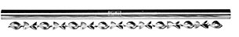
Figure 2.3 Koflo static mixer

A screen mixer also aids in the mixing of air and hydraulic fluid. A screen mixer was constructed using two washers, a screen, and J. B. weld. This was then placed inside the clear tube as shown in Figure 2.4.

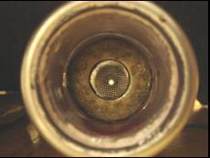
Figure 2.4 Screen mixer inside clear tube

2.2.2 Graduated cylinder
A graduated cylinder is necessary in the BEETA system to measure the amount of air in the outgoing hydraulic oil and air mixture. The graduated cylinder was custom fabricated by Polyfab to given specifications, see Figure 2.5. All the dimensions were determined by the analysis shown in Appendix B. From these calculations it was determined that the BEETA system could be measure between 99.99% and 97.93% volumetric percentage of hydraulic fluid.

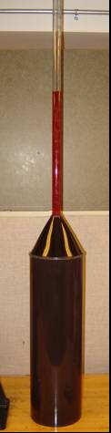
Figure 2.5 Graduated cylinder full of hydraulic fluid

The tank is transparent so that air bubbles can be visually seen leaving the hydraulic fluid. The cone shape between the bottom section and the graduated cylinder section helps air better settle out of the graduated cylinder. The fitting on the top allows for overflow and the fitting on the bottom allows for hydraulic fluid entry and exit.

2.2.3 Hydraulic fluid tanks
To store the hydraulic oil two hydraulic fluid tanks were purchased from McMaster Carr. The fluid tank is 30.2 L while the smaller dump tank is 11.4 L. The large fluid tank is adequately sized so that the system will not run out of hydraulic fluid while in operation. The smaller dump tank is sized so that in a closed loop setup the operator will have at least 4 minutes to set up all the valves and pressures before hydraulic fluid needs to enter the graduated cylinder.

2.2.4 Pressure gauges
Pressure gauges are necessary to allow the operator to be able to appropriately adjust all the valves during testing. A total of 6 pressure gauges were purchased from McMaster Carr. Low pressure gauges can read between 0 and 414 kPa, while the higher pressure gauges read between 0 and 690 kPa. Corrosive resistant gauges were purchased for use with the hydraulic oil. The gauge measuring the pressure of the hydraulic fluid exiting the bubble eliminator was purchased to have a built in flange to allow for easy installation. The pressure regulator for the incoming air came with a built in pressure gauge.

2.2.5 Mass flow meter
An air mass flow meter is necessary to measure the amount of air entering the deaeration device. For this the Omega FMA-A23-10 mass flow meter was purchased. This specific model has ±1% accuracy of full scale. This high level of accuracy will help yield more accurate measurements. The response time is 1 second, which is relatively long; however, the test will be performed in steady state conditions so response time is not an important characteristic. The meter is rated for up to 1700 kPa. This is much higher than the current BEETA system configuration can obtain; however, if in the future high-pressure tests are desired the BEETA system can be reconfigured and the meter will be able to handle the pressure. The model has a 0 to 5 volt output, to allow for the data acquisition card to electronically acquire and save data during testing.

The range of the flow meter must cover the target region of volumetric air concentration between 2% and 30%. To solve this meter was purchased to read flow rates between 0 and 15 SLM (Liters per minute at atmospheric pressure). This allows the BEETA system to be able to achieve a wide range of volumetric air concentrations depending on what the hydraulic fluid flow rate and pressure is as shown in Figure 2.6. This range is within the target region therefore, the maximum and minimum values shown in Figure 2.6 are ideal.

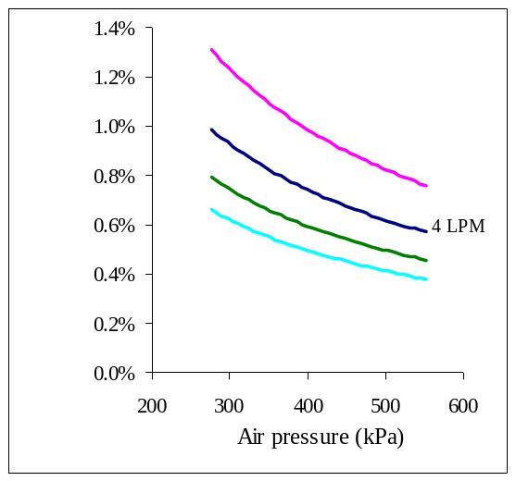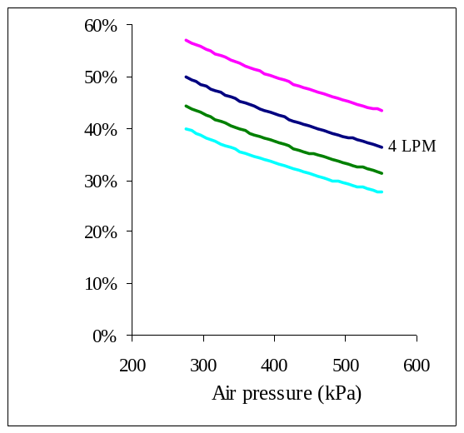
Minimum Achievable
Air Concentration
Maximum Achievable
Air Concentration
Figure 2.6 Minimum and maximum flow meter range

2.2.6 Borrowed items and petty cash items
In order to construct the BEETA system a number of different items were borrowed from the EPA. All of these items are specifically listed in Appendix E. Appendix D lists the petty cash items that were purchased from various hardware stores and Radio Shack.

2.3 Fabrication
The BEETA system was fabricated in the WuMRC using the items discussed in the previous section. Construction involved fabricating brackets to hold everything in place and routing all of the hydraulic lines.

2.3.1 Bracketry items
Bracketry items were fabricated to hold the necessary components in place. The lower shelve was needed to hold the hydraulic pump and the 30.2 L fluid tank. It also gives a place to mount the check valves. The lower shelf is made up of two 6’ long 2”x4” and a 6’ long ¾” x 1’ board as shown in Figure 2.7.

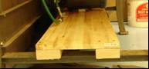
Figure 2.7 Lower shelf

The clear piping, the drip tank, outflow pressure gauge, valves 3 and 4, and the bubble eliminator must be mounted elevated from the table to allow for fluid to drain out of the system. This is accomplished using solid steel towers and a polycarbonate mounting bracket. The towers were borrowed from the WuMRC and the polycarbonate mounting bracket was fabricated using a ban saw and drill press.

In order to hold valves 1, 2, 5, 6, and 7 in place identical aluminum brackets shown in Figure 2.8 were made. These brackets were fabricated using a drill press and a ban saw. They are four inches long and have three small mounting holes on one side and one large 7/8” hole on the opposite side for mounting the valve.

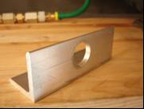
Figure 2.8 Valve bracket

2.3.2 Routing hydraulic lines
To allow the operator maximum space to work the BEETA system leaves as much table top surface clear as possible. To accomplish this task the majority of the fluid lines are routed underneath the table as shown in Figure 2.9. The clear plastic lines carry low pressure fluid while the green rubber lines carry high pressure fluid. All of these lines are necessary to complete the fluid diagram shown earlier in Figure 2.2.

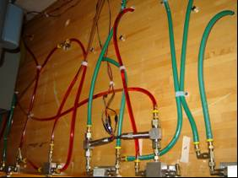
Figure 2.9 Fluid lines routed underneath BEETA system table

2.4 Electrical Setup and Data Acquisition
Flow information must be recorded during testing. To accomplish this task two fluid flow meters and the air mass flow meter are wired such that information can be recorded to a computer during operation. This data can then be analyzed after testing is complete.

2.4.1 Wiring schematic
The wiring configuration allows for all the meters to receive the necessary input voltage and for the signal generated to reach the data acquisition equipment. All three meters are wired as shown in the Figure 2.10. All the connections were soldered and heat shrunk to add durability to the system.
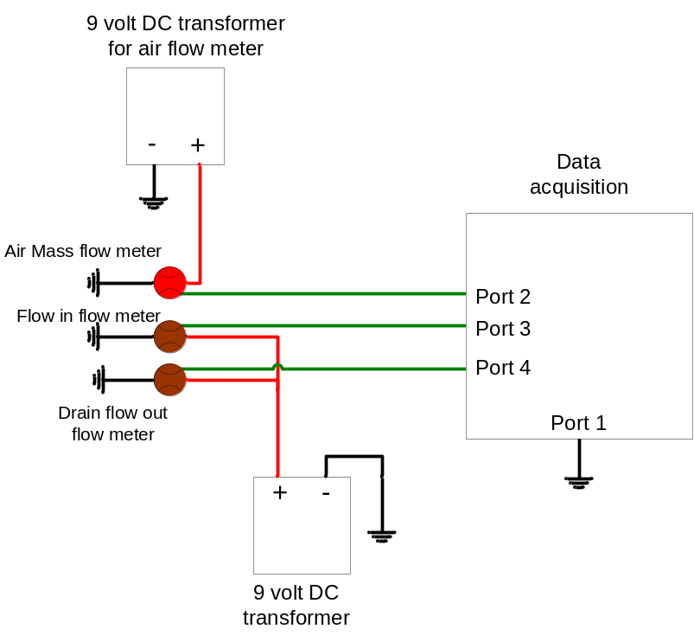

Figure 2.10 Electrical wiring diagram

2.4.2 Data acquisition
Data acquisition computer equipment is necessary to read and store data during testing. To acquire data from the meters a computer with a data acquisition card was borrowed from the WuMRC and set up next to the BEETA system. Several Labview programs were modified to create the program that is used for acquiring and saving the data from all three meters. The user interface of this program is shown in Figure 2.11. When this program is run data is stored in a text file. The information in the text file was then analyzed using the Matlab program shown in Appendix F.

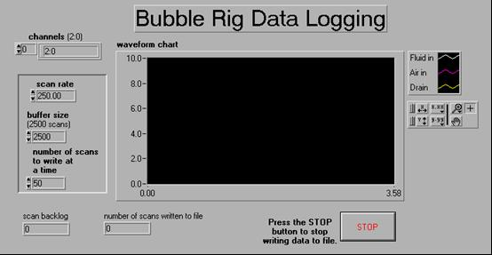
Figure 2.11 User interface for data acquisition

2.5 Procedure for Use
To operate the BEETA system a series of steps must be performed. These steps are listed below.

Step 1: Presetting all the valves
V5, V6, and V7 must be closed. Next the V9 must be positioned to route hydraulic fluid into the dump tank. Valve 1 must be closed and V2 must be open. This configuration sets it so that when the BEETA system starts only air is flowing through the system. Valve three must be closed to help minimize the amount that the fluid tank with fill up at the beginning and V4 must be open to prevent pressure build up in the line. V8, must be closed to make it easier to adjust when the time comes. This starting valve configuration is shown in Table 3.

Table 1: Starting Valve Configuration
 | Open | Closed
Valve Number | V2, V4 | V1, V3, V5, V6, V7, V8

Step 2: Start air flow
All the meters need to be turned on so that the operator can easily read the air mass flow meter. Then using the pressure regulator and V2 the air pressure and flow rate is set to the desired value. The operator will have as much time as required for this operation because no hydraulic fluid will be running.

Step 3: Start hydraulic fluid flow
Once the hydraulic pump starts the operator will have approximately 4 minuets to reach step 5 before the dump tank overflows. The operator should be aware of the fluid height in the dump tank and must shut down the pump before overflowing occurs.

V1 must be completely open so as not to build up too high of a pressure. Next the hydraulic pump is turned on and fluid starts flowing. Using V1 and the relief valve the desired oil flow rate and pressure is set. This pressure must match the air pressure in order for bubbles to be produced. Adjustments in the system will need to be made to ensure the airflow rate, and air pressure are at the correct values.

Step 4: Back pressure
V7, V3 and V8 must be adjusted so that the hydraulic fluid level in the drip tank remains constant and the pressures and flow rates are as desired. V4 is also adjusted to help control the proper backpressure. These valves work together to control the backpressure of the system, and the drainage fluid flow rate.

Step 5: Begin test
Once all the pressures and flow rates are set accordingly the V9 is rotated to start filling the graduated cylinder. The data acquisition program is also started to record the data from the three meters at the beginning.

Step 6: Stopping the hydraulic fluid flow
V9 is turned to stop flowing hydraulic fluid into the graduated cylinder when the fluid reaches the top of the cylinder. V6 is opened, V2 is closed, and the hydraulic pump is turned off. With the aid of V5 fluid is drained from the graduated cylinder until it reaches the 200 ml mark.

Step 7: Final measurements and draining the system
The new fluid height is recorded after waiting 24 hours for the air to settle out. This measurement along with the original fluid height yields the volumetric concentration of air that was inside the hydraulic fluid that made it through the bubble eliminator.

To drain the system V2 through V7 must be opened. Blowing air through the system helps oil move into the fluid tank on the lower shelve.

Chapter 3. Performance Efficiency and Testing Results

Performance efficiency testing of cyclone bubble elimination is necessary to establish if this system is suitable for use in a dry sump pump system. This section describes how bubble removal efficiency is calculated, the experimental procedure, results of testing, a discussion on Suzuki et al. [Error: Reference source not found] dissolved gas studies, and conclusions that can be drawn from testing.

3.1 Bubble Removal Efficiency
The bubble removal efficiency, denoted as B_{rem}, is the value of most interest and was determined from data analysis using:

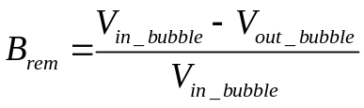 H_{final} > 0 (1)

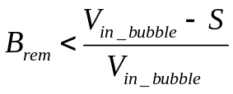 H_{final} < 0 (2)

V_{in_bubble} and V_{out_bubble} denote the volumetric concentration of air, at standard temperature and pressure, entering and exiting the cyclone bubble elimination device, respectively. H_{final} denotes the final fluid height (ml) as read by the graduated cylinder and 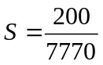 (maximum V_{out_bubble} value that can be read using the graduated cylinder).

V_{in_bubble} is found using Eq. (3) with the volumetric flow rate of incoming air at atmospheric pressure (V_{In_air}) and the incoming oil flow rate (V_{In_oil}). V_{In_air} is found using the air mass flow meter and V_{In_oil} is found using the incoming fluid flow meter and both are in units of L/min at standard temperature and pressure.
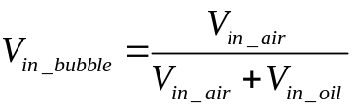 (3)

V_{out_bubble} is found using:

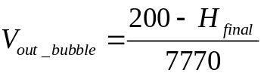 H_{final} > 0 (2)

If H_{final} < 0 an exact V_{out_bubble} cannot be determined but a less than value can be determined for B_{rem} (on all tables this is shown as a pink symbol) using Eq. (2). The Matlab program in Appendix F was used to collect the thousands of lines of data found from testing, and determine the average flow rate during each test.

3.2 Experimental Procedure
A total of 20 experiments were conducted to determine the B_{rem} over a wide range operating conditions. To accomplish this task these experiments were designed to have varying V_{in_oil} values, and varying differences in vent and back pressure (P_{delta}) values as shown in Tables 2 and 3. For all tests the back pressure was held at a constant 138 kPa, as recommended by GE-Totten as optimum; however, GE-Totten did not recommend an optimum vent pressure [Error: Reference source not found].
Table 2: Low Flow Rate Testing
V_{in_oil} (L/min) | P_{delta}
1.45 | Between 0 and  48.3 kPa
1.47 | Between 0 and  48.3 kPa
1.52 | Between 0 and  48.3 kPa
1.55 | Between 0 and  48.3 kPa
1.66 | Between 0 and  48.3 kPa
1.70 | Between 0 and  48.3 kPa
1.80 | Between 0 and  48.3 kPa
2.06 | Between 0 and  48.3 kPa
Table 3: High Flow Rate Testing
P_{delta} (kPa) | V_{in_oil}
0 | Between 5  and 6 L/min
13.8 | Between 5  and 6 L/min
27.6 | Between 5  and 6 L/min
0 | Between 4  and 5 L/min
13.8 | Between 4  and 5 L/min
27.6 | Between 4  and 5 L/min
0 | Between 3  and 4 L/min
13.8 | Between 3  and 4 L/min
27.6 | Between 3  and 4 L/min
0 | Between 2  and 3 L/min
13.8 | Between 2  and 3 L/min
41.4 | Between 2  and 3 L/min

P_{delta}, V_{in_oil}, and V_{in_air} are all interrelated in the BEETA system. Meaning when one value changes the other two will also change making control of testing values very difficult on the BEETA system. Lower flow rate tests vary V_{in_oil} between 1.45 and 2.06 L/min and allowed P_{delta} to be between 0 and 48.3 kPa as shown in Table 2. Higher flow rate tests, focused on testing three different P_{delta} values and within ranges of V_{in_oil} as shown in Table 3. All the data analysis takes into account only B_{rem}; therefore, varying V_{in_bubble} values are accounted for in the performance analysis of the device.

3.3 Results -- Effect of Flow Rate
Increasing the flow rate closer to 6 L/min yields a negative correlation to B_{rem}. This is the opposite of what GE-Totten claims should happen [Error: Reference source not found]. According to GE-Totten the optimum flow rate is 6 L/min [Error: Reference source not found]. This discrepancy occurs in the BEETA system because the bubble size and amount of dissolved gas vary depending on V_{in_oil}. At high flow rates the bubbles are extremely small and there are higher concentrations of dissolved gas due to the increased pressures and increased mixing abilities of the BEETA system. In the BEETA system the static and screen mixer increase their mixing ability at higher flow rates. Also as the flow rate increases the pressure increases which leads to higher solubility, which intern creates a greater amount of dissolved gas in the oil. Therefore, the higher the flow rate the smaller the bubble size and the more dissolved gas the cyclone bubble eliminator must contend with.

The BEETA system’s creation of smaller bubbles (<0.75 mm radius) and dissolved gas at high flow rates overcomes the optimum efficiency effect and therefore as the flow rate increases towards 6 L/min the B_{rem} decreases drastically. This effect is shown in Figure 3.1 which illustrates all the tests conducted at various V_{in_oil} values and various P_{delta} values. Note that the data points shown in pink illustrate that the exact value is unknown but the value lies somewhere below that point. Figure 3.1 shows unacceptably low levels of air removal for the small bubble and dissolved gas mixture. The maximum achievable flow rate by the BEETA system was 5.6 L/min. The system was unable to achieve higher flow rates because of system pressure limitations.

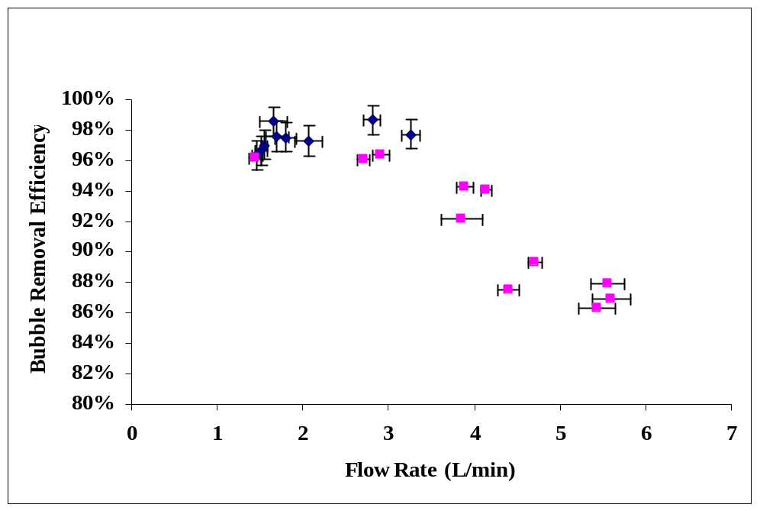
Large bubbles easily removed
Small bubbles / dissolved gas mixture creates unacceptably low performance
Figure 3.1 Cyclone bubble elimination performance

The error was calculated using the error associated with the precision of the graduated cylinder and the deviation in the readings found in the flow meters during testing. Exact stable conditions could not be created for the flow rates during the test. There was some fluctuation due to the increasing pressure as the graduated cylinder filled with fluid. To account for this slight change during each test, data was recorded at three different times (beginning of test, middle of test, and end of test). Error was then formed based on the standard deviations between these tests. The error bars were then placed on Figure 3.1 based on this error.

3.4 Results -- Effect of Vent Pressure
For the lower flow rates it was visibly and experimentally shown that the higher the P_{delta} value the better the cyclone bubble elimination performance. At higher flow rates the optimum P_{delta} was difficult to visibly determine and experimentation showed no correlation between B_{rem} and P_{delta}.

For low oil flow rates (<3 L/min) it could be seen visually that increasing P_{delta} created increased bubble removal. This statement is also supported by experimental findings shown in Figure 3.2.

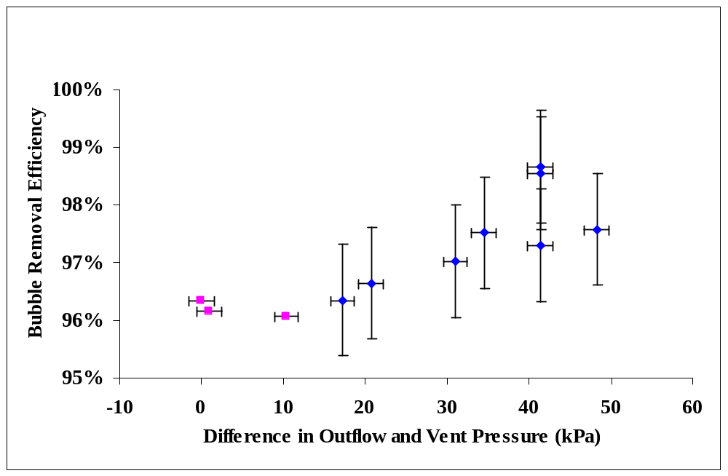
Given low flow rate, B_{rem} increases with increasing P_{delta}
Figure 3.2 Increasing P_{delta} effect on low flow rates
For high flow rates (>3.5 L/min) there was no correlation between B_{rem} and P_{delta} as shown in Figure 3.3. Figure 3.3 also shows unacceptably low bubble removal efficiency (<95%) is found regardless of P_{delta} choice.

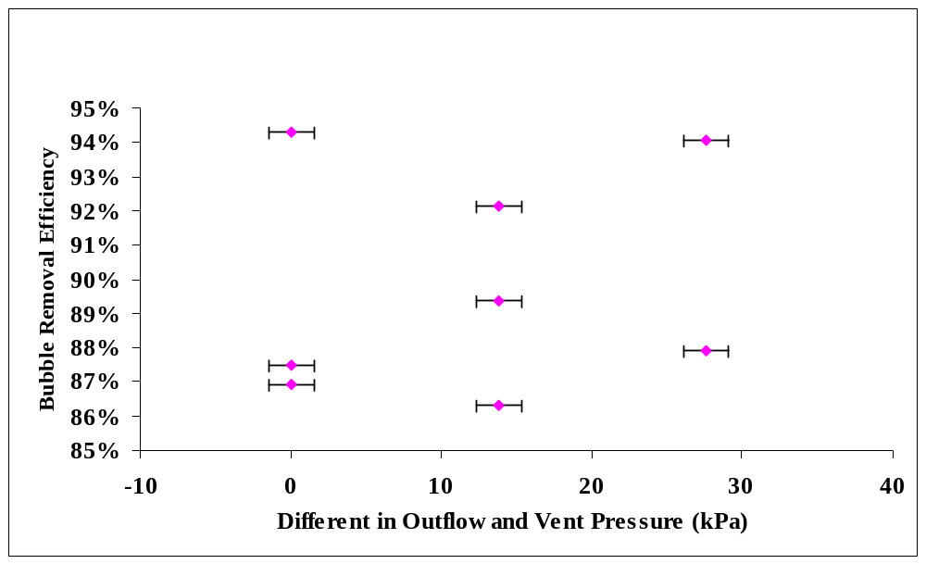
Much too low bubble removal rate to be used on dry sump pump system
Figure 3.3 Lack of efficiency to varying P_{delta}

3.5 Comparison with Suzuki et al. [Error: Reference source not found] Testing Results
Suzuki et al. [Error: Reference source not found] testing results in SAE paper 982037 support our findings, which show that cyclone bubble eliminators are unable to remove large quantities of dissolved gas. Published in the SAE paper is Figure 3.4. This experiment involves oxygen being dissolved in hydraulic oil and the same mixture circulating a 16 L volume of fluid through a cyclone bubble elimination device.
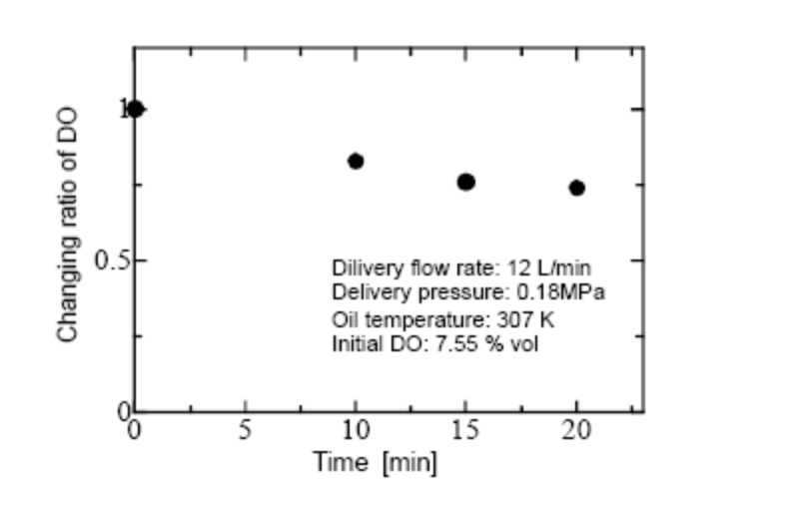
Figure 3.4 Suzuki et al. testing results [Error: Reference source not found]

By taking Suzuki et al. [Error: Reference source not found] data and calculating the average percentage of dissolved gas removed each time the fluid passes through the device Figure 3.5 is formed. This helps to better relate Suzuki et al. [Error: Reference source not found] data with our own. As can be seen in Figure 3.5 the dissolved gas removal rate is less than 3% per pass through the bubble elimination device. This proves cyclone bubble eliminators cannot remove large percentages of dissolved gas in a single pass through the device and it correlates with our findings of poor efficiency at removing dissolved gas.

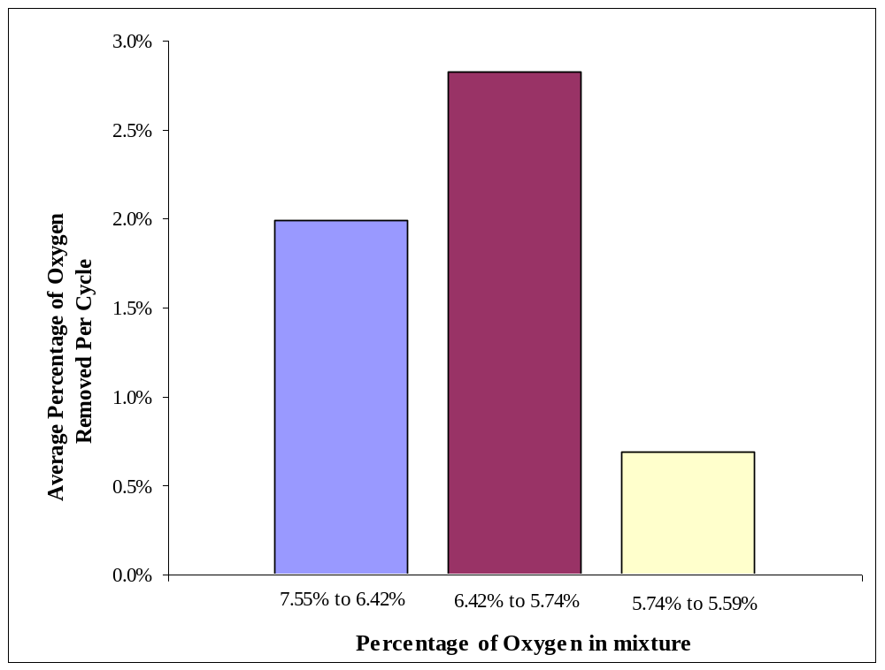
Low dissolved gas removal rates
Figure 3.5 Suzuki et al. testing results reorganized [Error: Reference source not found]

3.6 Conclusions from Testing
Testing results reveal that the cyclone device removes less than 95% of small bubbles (<0.75 mm radius) and dissolved gas mixture, which is unacceptable for a dry sump pump application. Given the limited range of the graduated cylinders testing capabilities it is impossible to determine by exactly how much the cyclone device would need to improve to make it capable of being used in a dry sump pump system. Cyclone bubble elimination can effectively remove large bubbles but fails at removing large amounts of small bubbles and dissolved gas.

Chapter 4. Theory of Dissolving Gas and Forces on Bubbles
Understanding the theory of dissolving gas and the forces that act on bubbles helps the project understand why cyclone bubble elimination has poor bubble removal efficiency and which other bubble removal techniques can potentially have higher bubble removal efficiency. This section will explain the theory of dissolved gas, forces which act on air bubbles, and the dependence of varying effects (bubble size, pressure, and temperature) have on bubbles naturally settling out of fluid.

4.1 Henry’s Law for Dissolved Gas
Henry’s Law, given in Eq. (5), states that the concentration (c) of gas that can be dissolved in a liquid is directly proportional through the constant of solubility (k) to the pressure exerted above the liquid (P).

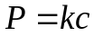 (5)

When the bubbles become finely mixed into the fluid some of the gas will directly dissolve into the fluid. This increases the compressibility of the fluid and as pressure changes during operation the air can undissolve and form bubbles, which lead to the many problems discussed earlier [Error: Reference source not found].

The constant of solubility (k) varies depending on the solution, the gas, and the temperature. The solubility of gases decreases with increasing temperature. The solubility constants for different gases in hydrocarbon oil are given in Table 4. The larger the k value the more difficult it is for the gas to dissolve into the oil.
Table 4: Constants of Solubility in Hydrocarbon Fluid []
Gas being mixed into hydrocarbon oil | Constant k at 70º F (L*atm/mol)
H₂ | 266.15
N₂ | 204.63
Estimated value for Air | 186.88
CO | 169.58
O₂ | 120.14
CH₄ | 55.51
CO₂ | 26.445

4.1.1 Cyclone pressure effect on dissolved gas
The cyclone bubble eliminator creates an area of low pressure in the center, which decreases the solubility, thereby helps to undissolve the air from the fluid. According to Suzuki et al. [Error: Reference source not found], cyclone bubble elimination creates a maximum pressure drop of -80 Pa (180 Pa). By Henry’s law this will decrease the solubility of 138 kPa fluid by 0.13053 %. This is not nearly enough to fully pull out all of the dissolved gas, and the fluid is only exposed to the reduced pressure for about 8 seconds (with a flow rate of 6 L/min). This creates a situation where the bubble eliminator is unable to pull out any substantial portion of dissolved gas in a single pass, which supports testing results.

4.2 Forces Acting on Air Bubble
Drag, buoyancy, and forces associated with acceleration are the primary forces, which act on bubbles to help dictate their motion in fluid other than the force of the fluid flowing. These forces can be optimized to allow bubbles to quickly relocate to a desired area where they can then be removed.

4.2.1 Drag
Drag is the force that opposes the velocity of the bubble. This is a hindrance when trying to forcibly move a bubble to a desired location. The drag primarily depends on the viscosity of the fluid and the bubble diameter. Larger bubble diameters and more viscous fluid equate to greater drag forces.

Often when the bubbles are very small the drag force is much larger than the other forces that can act on it. Therefore, the bubbles are more likely to remain in the fluid for a long time. The drag force is responsible for the long amount of time (1 day in our experiments) for the air bubbles to settle out of the fluid.

4.2.2 Buoyancy
Buoyancy is a bubble force in the direction of the pressure gradient (towards lower pressure). It occurs whenever a pressure gradient exists. When gravity causes the pressure gradient the pressure acting on the bubble is not equal due to the change in depth thereby creating a situation where there is more upward force than downward force. This effect is illustrated in Figure 4.1.

Gas
Liquid

Increasing pressure from fluid height

Uneven pressure

Figure 4.1 Buoyancy force on bubble

By Archimedes principle the buoyancy force is equal to the weight of the fluid displaced. Therefore, the larger the bubble diameter the greater the buoyancy force. Once a bubble is formed it contains a specified amount of mass (m). The volume (V) is then dependent on the pressure (P) and temperature (T) by the ideal gas equation Eq. (6) where R is the ideal gas constant. Therefore, by increasing the temperature and decreasing the pressure the air bubble will become larger thereby increasing the buoyancy force.
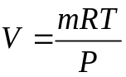 (6)

4.2.3 Centrifugal force
In cyclone bubble eliminators the oil is spun around in a circle. This continual change in direction creates an centripetal acceleration that in turn creates an outward centrifugal force (F_{c}) as given in Eq. (7), where m is the mass of the particle, ω is angular velocity and r_{p} is the radius of rotation perpendicular to the direction of motion. F_{c} pulls stronger on the denser parts of the fluid thereby forcing the bubbles towards the center of the cyclone where they can be moved out. The drag force on the bubbles works against this process.

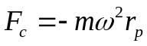 (7)

4.3 Bubbles Naturally Settling out of Fluid
Deaeration can take place by allowing the buoyancy force to slowly pull air to the surface and out of the mixture. This section explores the theory behind how bubble size, pressure, and temperature effect time needed for air to settle out of a fluid.

4.3.1 Dependence on bubble size
By combining the drag force and the buoyancy force, Stokes Law given in Eq. (8) can be formed based on gravity (g), bubble radius (r) and kinematic fluid viscosity (v) to estimate the terminal bubble rise velocity (V_{rise}) given the bubble radius is less than 0.75 mm []. If the bubbles are too large the bubble shape is prone to changing which leads to oscillations and turbulence that changes the drag coefficient.

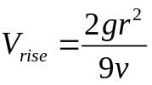 (8)

From this equation Figure 4.2 was formed with the hydraulic fluid having a kinematic viscosity of 34 cSt as given by Mobile for their hydraulic fluid []. This illustrates the strong dependence bubble size has with how quickly bubbles can settle out of oil.

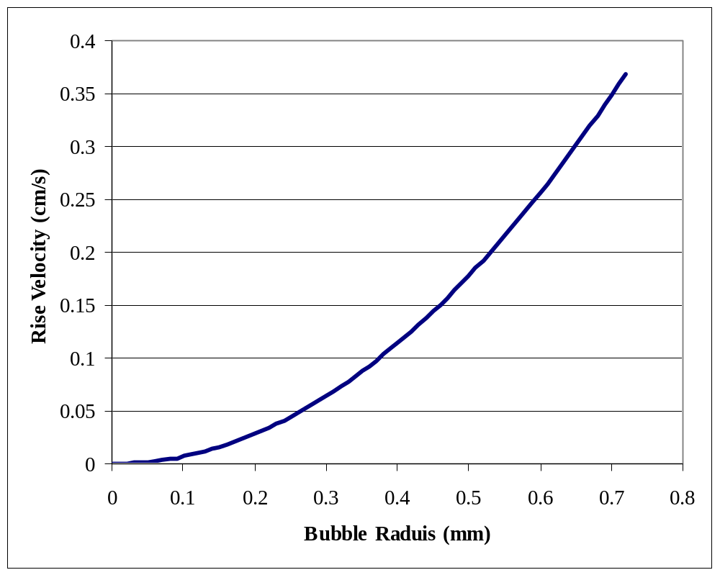
Figure 4.2 Rise velocities strong dependence on bubble radius

4.3.2 Dependence on pressure above fluid
Decreasing the pressure above the fluid increases V_{rise} by Eq. (9) where V is the volume of the bubble and this is given by Eq. (10).

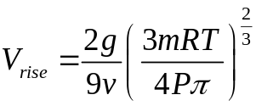 (9)

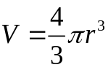 (10)
By decreasing the pressure above the fluid the solubility decreases by Henry’s law (dissolved gas comes out) and the bubble size increase, thereby increasing the bubble rise velocity. The bubble radius is related to the pressure by the ideal gas law given in Eq. (6). Therefore Eq. (9) is formed by combining Eqs. (6), (8), and (10).

Figure 4.3 illustrates how decreasing the pressure helps air settle out faster. This figure uses initial bubble conditions of a radius of 0.4 mm at 1 atm and the relationship formed by Eq. (9). Note that Eq. (9) is only valid for bubbles with less than a 0.75 mm radius. To maintain this validity Figure 4.3 shows only when the bubble size is between 0.4 mm and 0.75 mm.

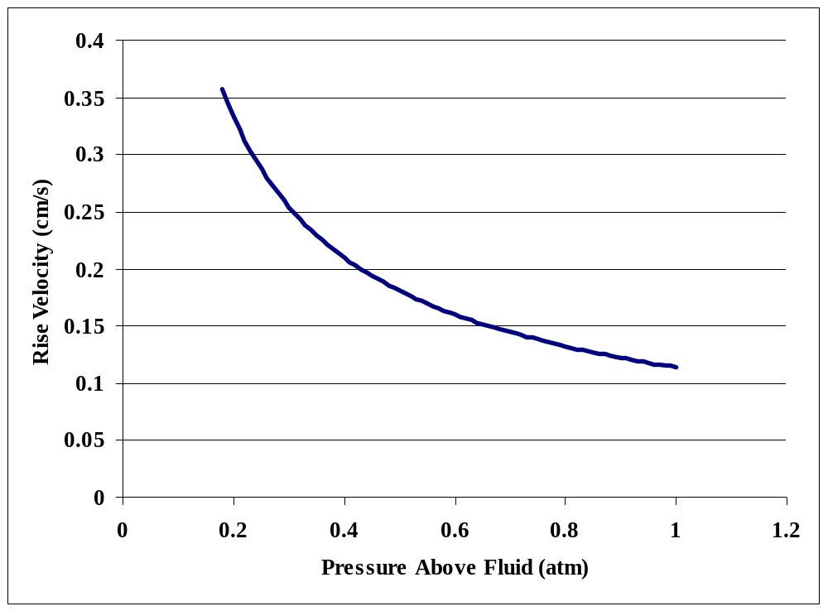
Figure 4.3 Low pressure bubble rise velocity effect

4.3.3 Dependence on temperature
Increasing the temperate helps to increase V_{rise} by Eq.(11) where A and b are constants based on temperature dependence of oil viscocity and T the temperature.
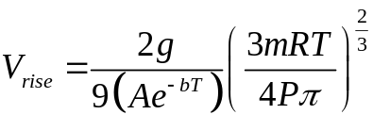 (11)

Increasing the temperature decreases the viscosity of the oil and it increases the bubble radius thereby increasing the buoyancy force on the bubble. This intern leads to an increase in V_{rise}.

Viscosity is related to temperature using an exponential model shown in Eq. (12) below, where A and b are constants. Using the two sets of conditions given by Mobil [Error: Reference source not found] for their hydraulic oil A=84291 and b=0.025 given v is in cSt and T is in Kelvin.

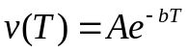 (12)

Combining Eq. (12) with Eq. (9) yields the relationship between temperature and bubble rising velocity given as Eq. (11). Figure 4.4 is formed based on this equation using a bubble of 0.4 mm radius at T=40ºC. As can be seen temperature has a strong influence on V_{rise.}
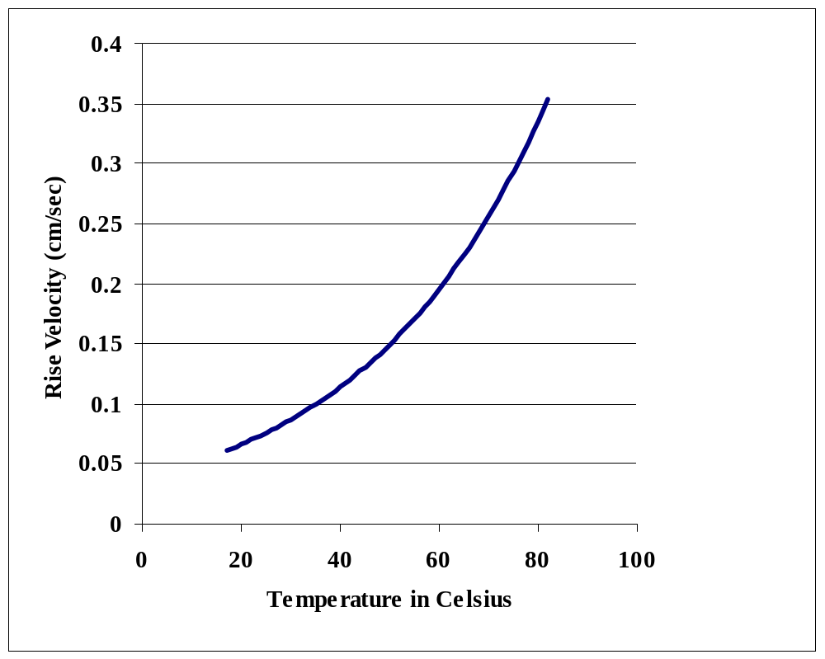
Figure 4.4 Temperature bubble rise velocity effect

4.4 Conclusions from Theory
The cyclone bubble eliminator can be effective at pulling out large bubbles, but is ineffective at pulling out small bubbles and dissolved gas due to the large drag forces and the lack of pressure gradient. Changing the gas to one with a higher k, increasing the bubble radius, decreasing the pressure above the oil, and increasing the temperature would all be helpful concepts in decreasing the amount of time gas takes to settle out of the oil.

Chapter 5. Conclusions and Recommendations

Testing results reveal that the cyclone device removes less than 95% of small bubbles (<0.75 mm radius) and dissolved gas mixture, which is unacceptable for a dry sump pump application. In the dry sump pump operation there will surely be small air bubbles and gas dissolving directly into the fluid. Therefore, we recommend systems be tested to remove the dissolved gas and small bubbles. There are three main ways that dissolved gas can be removed; by heating it, by changing the type of gas, and by dropping the surface pressure. We recommend all three of these options be experimented.

If a gas with a higher k is used instead of air in the dry sump pump it can greatly help inhibit the gases ability to mix with the fluid. Once the gas becomes dissolved into the fluid it becomes extremely more difficult to pull out. Therefore, by changing the gas we can help inhibit this process from occurring.

Heating the fluid can help to decrease the solubility. Naturally from pump friction the fluid will become warm inside the dry sump pump. Therefore, this situation will already occur to a certain extent. However, depending on its effectiveness the temperature can be increased even more to help the solubility issue.

The pressure of the fluid can be dropped before it reenters the main line to help pull dissolved gas and small bubbles out. The cyclone bubble eliminators are unique in that these devices can continually pass fluid through and create a pressure drop with the cyclone. However, it cannot create a great enough pressure drop and our system does not demand a continual flow of fluid. The dry sump leakage rate will not be constant; therefore, in order to use a cyclone device a complex system would need to be put in place to regulate a constant flow through the bubble eliminator. A system of tanks is suggested as a solution shown in Appendix G, which will allow for fluid to be exposed to a vacuum, thereby allowing the gas to undissolve from the fluid.

I recommend that a vacuum chamber concept along with heating and alternative gases be further investigated and work on using a cyclone bubble eliminator stop for the time being. Possibly if a large bubble problem arises the bubble eliminator can be put to use and further research can be done at that time. But from data it is evident that the bubble eliminator cannot effectively eliminate small bubbles and dissolved gas and therefore by itself cannot be used on a dry sump pump operation.
Appendix A: Survey Deaeration devices

A.1. SUMMARY
A collection of deaeration techniques was requested by the EPA for possible use in their hydraulic hybrid systems. Specifically, we were asked to focus on deaeration of oil coming from the lubrication side of the main dry-sump pump/motor. After considering current and new deaeration techniques, we have compiled a list of possible deaeration concepts. The purpose of this report is to present the researched deaeration concepts so that the trade offs of each system may be considered. A summary list of the main advantage or disadvantage of each system is given below. Ultimately a decision on a deaeration technique will be selected for implementation into one of the EPA’s hydraulic hybrid systems.

Degassing Technique | What to Note
Mechanical | Readily Available, Cost and Size Effective
Membrane | Large Size, Hard to Scale Up to Main Line
Settling Tank | Experimentation Required, But Feasible
NASA Design | Feasibility Unknown
Chemical Additive | Feasibility Unknown

A.2. CONCEPTS
Each deaeration concept is listed in the following pages. Each concept is given its own section followed by a description, availability, size, advantages and disadvantages. Many of these concepts will work well together as noted in each of the applicable concept description.

A.2.1. Mechanical Degassing
1. Description: In a degassing pump or chamber, fluid enters the pump and is spun quickly. The fluid is forced to the outside and entrained bubbles move to the center forming a column. The column of gas is then expelled from the system by opening a vent valve along with applying back pressure from an orifice down-stream of the pump. Dissolved gas can be removed from the fluid be applying a vacuum at the gas vent port.
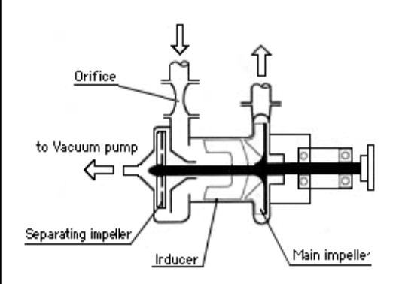
Figure A.1 Yokota’s Degassing Pump [Error: Reference source not found]

2. Availability: Two devices are currently on the market which mechanically separate air from oil. Yokota manufactures the degassing pump shown in Figure A.1. Another design manufactured by G.E. Totten and Associates LLC is shown in Figure A.2. G.E. Totten’s design is $700.00 per unit for model BM-6 []. Both designs work using the same basic principle described above. In the G.E. Totten’s design the pump is located down stream of the Bubble Eliminator and the fluid is spun using the geometry of the apparatus. The Yokota’s degassing pump incorporates the pumping work to spin the fluid. Yokota has given a price quote of $31,000 for their smallest pump [].

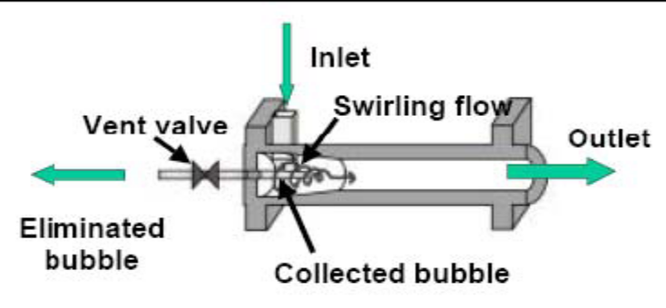
Figure A.2 G.E. Totten’s Bubble Eliminator
3. Size: The smallest model (BM-6) is produced by G.E. Totten and Associates LCC [Error: Reference source not found]. The BM-6 has a lower limit of 1.32 gpp [Error: Reference source not found]. The pump itself is small with dimensions of 6 cm diameter and a length of 16 cm [Error: Reference source not found]. Yokota’s smallest listed pump (ASP-310) has a lower limit of 2.64 gpp [Error: Reference source not found]. The pump is larger than the BM-6 with a length of 1.041 meters and a width of .33 meters[Error: Reference source not found,Error: Reference source not found]. It should also be noted that the ASP-310 weighs 120 kilograms [Error: Reference source not found].

4. Advantages:
- • Proven Technology being used in many different applications.
- • Two companies currently produce these systems
- • Can be integrated into the main-line system easily
- • Gas venting problem is already solved with these systems
- • Can easily be scaled up to degas main line
- • G.E. Totten’s Design will cost us $700.00
- • Low power consumption (extra 20 psi of pressure needed for degassing)
- • Small size
- • G.E. Totten and Yokota are interested in working with us

5. Disadvantages:
- • Expensive (Yokota’s Design is $31,000)
- • Flow rates are limited to above 5 liters per minute (1.32 gpm)
- • Companies have to custom manufacture our pumps
- • Complicated System
- • Manufacturing on our own would be difficult
- • Already Patented Technology

A.2.2. Membrane Degassing
1. Description: This type of degassing uses a membrane which allows gas flow, but not liquid (much like the bladder material). The system would be aided by a pressure difference already present after pumping and examples are shown in Figure A.3 below.
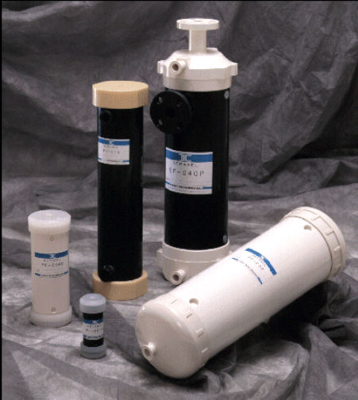
Figure A.3 Membrane degassers by Dainippon Ink and Chemicals Incorporated [Error: Reference source not found]

2. Availability: There are a few companies which produce membranes which are gas permeable and liquid impermeable. Dainippon Ink and Chemicals Incorporated and Compact Membrane Systems, Inc. are two examples of companies which have membranes for oil applications. Compact Membrane has a membrane which would work in our application and is willing to work with people at the EPA and the University of Michigan to develop a design solution. Dainippon Ink and Chemicals Incorporated’s model SEPAREL PF-28F will remove 50% of the dissolved gas at the 1.5 gpm flow rate we have specified [Error: Reference source not found,Error: Reference source not found]. This model is oil compatible. The bladder material is another option for a membrane system, as we know already that it allows for gas flow. Experimentation would need to be conducted to acquire degassing flow rates for the bladder material. We could also investigation building our own membrane system with other membrane materials.

- 3. Size: The SEPAREL PF-28F membrane degasser described in the previous paragraph has a diameter of 10.2 cm and a length of 44 cm [Error: Reference source not found]. This membrane degasser weighs 4.3 kg [Error: Reference source not found].

- 4. Advantages:
  - • Compact Membranes is interested in working with us
  - • Available from Dainippon Ink and Chemicals Incorporated
  - • Easily installed
  - • Passive System requiring little to no energy consumption
  - • Gas venting should be relatively easy as it shouldn’t contain any oil
  - • Simple System
  - • No moving parts

  - 5. Disadvantages:
- • Large Size
- • Cannot be easily scaled up for the mainline
- • Potentially expensive
- • Membrane degassers have been reported to clog

A.2.3 Settling Tank
1. Description: This concept allows gas to vent itself using a pressure drop in the system. Currently the system minimum in the main line is 60 psi. The pump reservoir trying to be degassed is at atmosphere, or very close to it. This pressure difference would allow much of the gas that would be present at 60 psi to disassociate from the fluid over an elapsed time or repeated cycles. The gas would then be ready to be vented by a method yet to be determined. An example of such a system is shown in Figure A.4.
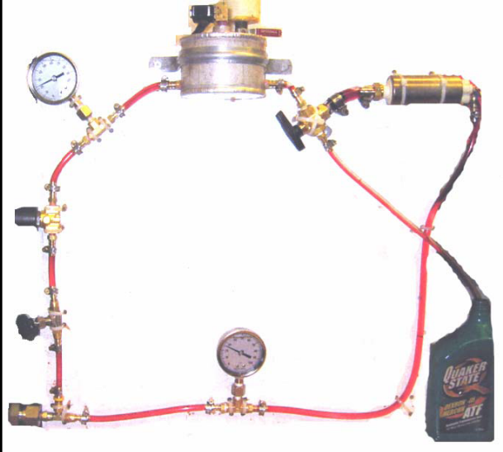
Figure A.4 Challenge X Team Degassing Project

2. Availability: Manufacturing this system ourselves will not pose a problem as it is a very simple system. A past Challenge X Team at the University of Michigan manufactured a proof of concept prototype of this type of system with success, as seen in Figure A.4.

3. Size: Experimentation needs to be conducted to get a size estimate. Data is extremely limited when looking at time scales for an oil-air surface to reach equilibrium.

- 4. Advantages:
  - • Simple Design
  - • Passive system with little to no power consumption
  - • Cost Effective
  - • Easy to manufacture
  - • No moving parts (may be required to vent gas)

- 5. Disadvantages:
  - • Experimentation needed to determine size
  - • A venting method needs to be determined
  - • Difficult to scale up to main line

A.2.4. Heating
1. Description: Heating the oil would be an enhancement which could be added to the other systems described. As temperature increases solubility of nitrogen in oil will decrease. This will speed up the processes, or increase the other concepts effectiveness. For example, using a settling tank in conjunction with a boiler would guarantee that all the dissolved nitrogen which could disassociate while in the main system, was removed while in the settling tank. The added heat could be taken from the exhaust minimizing the energy required to heat the oil.

2. Availability: The heating device could be manufactured by our team. The design of which, could be borrowed from other heating devices. AMS oil makes an ATF which is specifically made for high temperature applications []. This oil used with the heating elements will help limit temperature degradation.

3. Size: The size of the actual heating elements should be small relative to the size of the deaeration device. The location of the deaeration device would be limited by a heating technique. It would be necessary for the deaeration device to be near the exhaust to maximize efficiency.

4. Advantages:
- • Enhances deaeration process (allows for more entrained bubbles to be captured)
- • Low power consumption if using exhaust heat
- • Easily integrated with other systems
- • Inexpensive to manufacture

5. Disadvantages:
- • Limits deaeration device location
- • Adds more complexity to the system
- • Different ATF oil may be needed to meet new temperature requirements
- • High heat degrades all oils eventually

A.2.5 Vacuum
1. Description: A vacuum concept has been developed by a Challenge X team at the University of Michigan and is shown in Figure A.5. This system uses a valve attached to a main line or reservoir. The valve opens allowing the fluid to enter into a piston chamber. The valve closes then a vacuum is applied using the piston. Henry’s Law dictates that dissolved gas will then disassociate from the ATF. With some settling time the less dense gas moves to the top of the chamber where it is then ready for a venting method. This concept was intended to monitor the amount of gas present in the fluid. The idea of using a vacuum could be combined with a setting tank concept. Applying a vacuum using a pump to a reservoir will increase the efficiency of a settling tank.
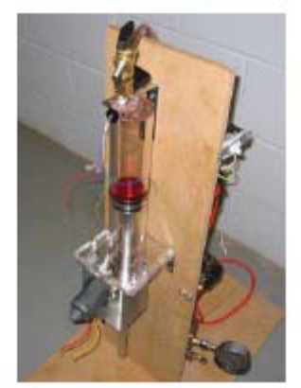
Figure A.5 Challenge X Vacuum Concept

2. Availability: This concept would need to be manufactured by us. The concept is simple and should not pose any manufacturing problems that could not be overcome with the machines and equipment available to our team. The Challenge X team had some success in manufacturing a proof of concept prototype as shown in Figure A.5.

3. Size: This concept would be near the size of the settling tank concept. With the limited data on time for air-oil surface equilibrium the size of these concepts is still unknown. The reservoir in theory would be smaller than a settling tank without an applied vacuum. Added bulk would be present in the needed vacuum pump or piston.
- 4. Advantages:
  - • Simple design
  - • Manufactured in-house
  - • Cost Effective
  - • Low power consumption (vacuum pump)
  - • Enhances settling tank deaeration

5. Disadvantages:
- • Experimentation needed to determine size
- • Difficult to scale up to main line
- • A venting method needs to be determined

A.2.6 NASA Fluid Bubble Eliminator
1. Description: This concept (as seen in Figure A.6) uses the same principles as G.E. Totten’s Bubble Eliminator. The main difference is in the gas venting method. In the NASA design a gas permeable, liquid impermeable membrane is used to separate the gas and liquid. This design was originally intended for “liquid flowing relatively slowly in a bioreactor system in microgravity” as stated by NASA’s website [Error: Reference source not found]. Experimentation has not been done on the feasibility of this method on Earth.

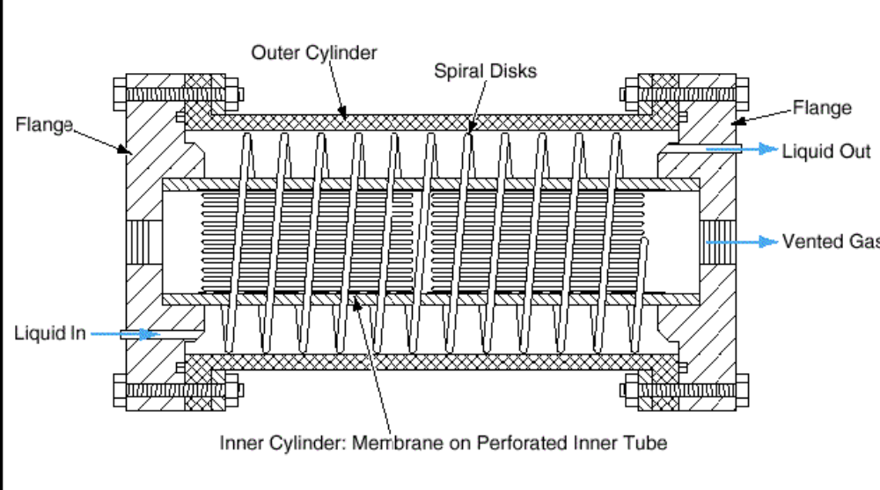
Figure A.6 NASA’s fluid bubble eliminator [Error: Reference source not found]

2. Availability: This design is patented by the Johnson Space Center. We would need to design the system and most likely contract out the manufacturing for some parts of the deaeration device. Material experimentation with respect to the membranes will be necessary as well as flow rate experimentation. Flow rate experimentation is needed to find the necessary acceleration on Earth to separate entrained bubbles and liquid.

3. Size: The size of such a system would be dependant on flow rate experimentation. The size will also be determined by the membrane surface area needed for gas separation from the liquid.

4. Advantages
- • No moving parts
- • Passive system requiring little power input
- • Gas venting problem is solved in design

5. Disadvantages
- • Complicated System
- • Difficult to manufacture
- • Experimentation needed to determine feasibility on Earth

A.2.7 Chemical Additive
- 1. Description: A chemical additive such as Zeolite could be used to remove nitrogen and at the same time, absorb a minimal amount of ATF. Zeolite works by allowing a fluid to pass through its crystal structure while trapping the unwanted gas.

- 2. Availability: Ralph Yang of the Chemical Engineering Department of the University of Michigan has expressed interest in working with us on this concept [Error: Reference source not found]. As of yet, little information is readily available on Zeolite in this application. If the EPA is interested in pursuing a chemical additive solution, Ralph Yang will be our main contact in further research.

- 3. Size: Experimentation will need to be conducted to establish size of a Zeolite reservoir. Experimentation will also need to be done to determine the amount of Zeolite needed to meet our aeration specifications.
- 4. Advantages:
  - • Requires little power consumption, pumping energy increases needed to pass fluid through Zeolite
  - • Simple System
  - • No moving parts
  - • Gas venting is taken care of with removal of old Zeolite

- 5. Disadvantages:
  - • Experimentation needed to determine size and amount of Zeolite
  - • Zeolite is expensive
  - • May be difficult to scale up to main line
  - • After an undetermined interval of time old Zeolite will need to be replaced with new Zeolite

A.3 CONCLUSIONS AND RECCOMENDAIONS:
Based on my research the mechanical degassing device is most promising. It is available for $700.00. It is small in size and requires little energy input. Looking towards the future the device could be implemented into the main line.

The disadvantages of the other systems are hindered by their development time or the ability to scale the idea up to the main line. Membrane degassing devices are quite large, making them unrealistic to scale up to the main line. A settling tank will require more experimentation before we know the exact size needed for our flow requirements (even more experimentation will be needed for the described enhancements). The NASA design combines membrane and mechanical degassing, which has not been verified to work on Earth. Chemical additives may work, but experimentation will be needed to determine its effectiveness. For these reasons, we recommend a mechanical degassing method be purchased for further tested.

Appendix B: Sizing of Graduated Cylinder
Minimum readable change | B (ml) = | 1 |  |  | D  C
Height of cylinder | D (cm tall) = | 40
Volume of C | C(ml) = | 200
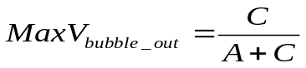 |  | V_{bubble_out} | 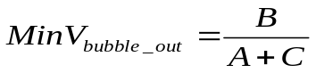
A (gal)= | A (ml) | Maximum | Minimum
1.89 | 1893 | 0.095570 | 0.000478
3.79 | 3785 | 0.050183 | 0.000251
5.68 | 5678 | 0.034024 | 0.000170
7.57 | 7571 | 0.025737 | 0.000129
9.46 | 9464 | 0.020696 | 0.000103
11.36 | 11356 | 0.017307 | 0.000087
13.25 | 13249 | 0.014871 | 0.000074
15.14 | 15142 | 0.013036 | 0.000065
17.03 | 17034 | 0.011605 | 0.000058 |  | A
18.93 | 18927 | 0.010456 | 0.000052
20.82 | 20820 | 0.009515 | 0.000048
22.71 | 22712 | 0.008729 | 0.000044
24.61 | 24605 | 0.008063 | 0.000040
26.50 | 26498 | 0.007491 | 0.000037
28.39 | 28391 | 0.006995 | 0.000035
30.28 | 30283 | 0.006561 | 0.000033
32.18 | 32176 | 0.006177 | 0.000031
34.07 | 34069 | 0.005836 | 0.000029
35.96 | 35961 | 0.005531 | 0.000028

Appendix C: Bill of Materials
Part Needed | Company | Phone | Part Number | Qu. | Cost (each) | Total
Mixer | Koflo | 847-516-3700 | stratos part no. 3/8-21 | 1 | $117.00 | $117.00
Dump tank | McMaster Carr | 630-833-0300 | 62945K12 | 1 | $146.13 | $146.13
Fluid tank | McMaster Carr | 630-833-0300 | 62945K14 | 1 | $228.35 | $228.35
measuring tank | Polyfab | 978-657-7704 | custom made | 1 | $980.00 | $980.00
mass flow meter | Omega | sales: 1-888-TC-OMEGA | FMA-A23-10 | 1 | $544.00 | $544.00
clear fittings for PVC pipe | McMaster Carr | 630-833-0300 | 9161K53 | 7 | $5.85 | $40.95
8' clear section of PVC pipe | McMaster Carr | 630-833-0300 | 49035K85 | 1 | $21.28 | $21.28
Clear PVC T | McMaster Carr | 630-833-0300 | 9161K33 | 1 | $9.54 | $9.54

Continued on next page.

Part Needed | Company |  | Phone | Part Number | Qu. | Cost (each) | Total
air regulator and gauge | McMaster Carr |  | 630-833-0300 | 4246k61 | 1 | $42.98 | $42.98
mounting bracket |  |  | 630-833-0300 | 4246K11 | 1 | $5.58 | $5.58
grade 1A air pressure gauge |  |  | 630-833-0300 | 3708k21  0-60psi | 1 | $26.32 | $26.32
grade 1A air pressure gauge |  |  | 630-833-0300 | 3708k21  0-100psi | 1 | $26.32 | $26.32
grade 1A oil pressure gauge |  |  | 630-833-0300 | 4088K3  0-100psi | 2 | $48.65 | $97.30
grade 1A oil pressure gauge (flange) |  |  | 630-833-0300 | 4088K7  0-60 psi | 1 | $57.07 | $57.07
Barb fitting | Grainger |  | 1-888-361-8649 | 5A247 | 35 | $2.05 | $71.75
Petty cash items | various hardware stores and Radio Shack, for details see petty cash table |  |  |  |  |  | $167.96
 |  |  |  |  | Total | $2,582.53

Appendix D: Petty Cash Spent
Company | Date | Item Description | Used For | Cost
Ace Hardware | 10/25/2006 | box of wood screws | Mounting screws for ball valve brackets | 4.23
Ace Hardware | 11/2/2006 | fine sand paper | Used to Polish bubble viewing tube | 7.37
Ace Hardware | 11/11/2006 | Bolts, nuts, and washers | Mounting various parts of the BEETA system | 12.49
The Home Depot | 10/26/2006 | 2 2"X4" boards of wood | Lower shelve support | 4.18
The Home Depot | 11/5/2006 | zip ties and hose clamps | Mounting various parts of the BEETA system | 9.84
The Home Depot | 11/11/2006 | 2 buckets and various hose clamps | buckets for transporting fluid, hose clamps for mounting | 24.48
The Home Depot | 10/31/2006 | PVC glue and primer, nuts and bolts | PVC glue and primer used to join PVC together | 12.01
The Home Depot | 11/7/2006 | hose clamps, wood drill bit | Wood drill bit used to drill holes in the BEETA system table | 12.54
Carpenter Brothers | 11/16/2006 | Tubing | Used for low pressure lines on the BEETA system | 9.22
Harbor Freight Tools | 11/5/2006 | Teflon tape, fittings, Air hose | Used throughout the BEETA system | 19.65
Carpenter Brothers | 12/9/2006 | J. B. Weld | Screen filter construction | 5.08
Carpenter Brothers | 12/8/2006 | Electrical connectors and electrical tape | Wiring of the BEETA system | 8.23
Radio Shack | 12/8/2006 | AC-DC transformer and wire | Powers fluid flow meters | 38.64
 |  |  | Total | 167.96

Appendix E: Items Borrowed from EPA

Quantity | Item Borrowed
2 | Swagelock R9FFB0201B - Male Quick Disconnect
2 | Swagelock R9GBKA005B - Female Quick Disconnect
6 | 6 1/4" Butech 2-way Valves Janus K63
2 | 1/4" Butech 3-way Valve Janus 3-K63
1 | Parker NV400S Throttle Valve with Handle (Gray)
1 | Deltrol CMM25B Brass Check Valve
1 | Parker C400S Check Valve
1 | Jayco #312 1/2" 80psi Bronze Relief Valve
2 | Flow Technologies FT6-8AEU3-LEA-2034 Flow meters
1 | Flow Technologies A1-5-C-V2-1-1 (991031) RF Pickoff
1 | Flow Technologies 27-94057-110 RF Pickoff
1 | Flow Technologies 30880-101 Magnetic Pickoff
7 | 20 Male Pipe to -16 Male JIC adapter
1 | Delta-Power 1 hp electric motor with A-23 gear pump

JIC #4 Fittings
Quantity | Type
12 | 90deg male-female
11 | straight male-male
2 | straight female-female
1 | 45deg male-female
7 | T male-male-female
3 | T all female
1 | T all male
2 | T male-female-male
NPT to JIC Fittings
Quantity | Size | Type
3 | NPT 1/4" to JIC #4 | male-male
4 | NPT 1/4" to JIC #4 | female-male
4 | NPT 1/4" to JIC #4 | male-female
2 | NPT 3/16" to JIC #4 | female-male
2 | NPT 1/2" to JIC #6 | female-male
2 | NPT 1/2" to JIC #8 | male-female
7 | NPT 1" to JIC #16 | male-male
JIC to JIC Conversion Fittings
Quantity | Size | Type
2 | JIC #6 to JIC #4 | female-male
2 | JIC #8 to JIC #4 | female-male
2 | JIC #8 to JIC #4 | male-male
3 | JIC #12 to JIC #4 | female-male
7 | JIC #16 to JIC #4 | female-male
1 | T JIC #4 | male-male-female
Barb Fittings
Quantity | Size | Type
16 | JIC #4 to 1" barb | female-barb
1 | JIC #12 to 1/4" barb | female-barb
1 | 3/4" NPT to 1" barb | male-barb

Appendix F: Matlab Program for Data Collection Analysis
clear all

% Reads Data output from BEETA system

A=textread('switchdiriction.txt');

%Inflow fluid
%%%%%%%%%%%%%%%%%%%%%%%%%%%%%%%%%%%%%%%%%%%%%%%%%%%%%%
%%%%%%%%%%%%%%%%%%%%%%%%%%%%%%%%%%%%%%%%%%%%%%%%%%%%%%

persec=A(1,1);
count=-1;
k=2;
frequency(1)=0;
time(1)=0;
last=1;

for i=2:(length(A)-1)
count=1+count;
point=A(i,1);

%if point is low
if point<.1

%if end of wavelength occurs
if last==1
period(k)=count;
time(k)=time(k-1)+count*1/persec;
count=0;
k=k+1;
end

last=0;
end

%if point is high
if point>4.5;
last=1;
end

end

frequency=1./(period*(1/persec));

sum=0;
num=0;
for i=3:length(frequency)
sum=frequency(i)+sum;
num=1+num;
end

average_frequency=sum/num;
frequency(1,2)=average_frequency;

%outgoing fluid
%%%%%%%%%%%%%%%%%%%%%%%%%%%%%%%%%%%%%%%%%%%%%%%%%%%%%%
%%%%%%%%%%%%%%%%%%%%%%%%%%%%%%%%%%%%%%%%%%%%%%%%%%%%%%

count=-1;
k=2;
frequency2(1)=0;
time2(1)=0;
last=1;

for i=2:(length(A)-1)
count=1+count;
point=A(i,3);

%if point is low
if point<.1

%if end of wavelength occurs
if last==1
period2(k)=count;
time2(k)=time2(k-1)+count*1/persec;
count=0;
k=k+1;
end

last=0;
end

%if point is high
if point>4.5;
last=1;
end

end

frequency2=1./(period2*(1/persec));

sum=0;
num=0;
for i=3:length(frequency2)
sum=frequency2(i)+sum;
num=1+num;
end

average_frequency2=sum/num;
frequency2(1,2)=average_frequency2;

%air incoming
%%%%%%%%%%%%%%%%%%%%%%%%%%%%%%%%%%%%%%%%%%%%%%%%%%%%%%
%%%%%%%%%%%%%%%%%%%%%%%%%%%%%%%%%%%%%%%%%%%%%%%%%%%%%%

airvolt=rot90(A(:,2));
time3= 0:1/persec:(length(airvolt)-1)*(1/persec);
average_voltage=mean(airvolt);

%Solutions
%%%%%%%%%%%%%%%%%%%%%%%%%%%%%%%%%%%%%%%%%%%%%%%%%%%%%%%
%%%%%%%%%%%%%%%%%%%%%%%%%%%%%%%%%%%%%%%%%%%%%%%%%%%%%%%

average_voltage
average_frequency2
average_frequency
inflow_rate=average_frequency*.0097+.014
drainflow_rate=average_frequency2*.0097+.014

plot(time,frequency,time2,frequency2)
title('Hydraulic Flowmeter Data')
xlabel('Time (seconds)')
ylabel('Frequency (hz)')
legend('Inflow','Drainage flow')
figure

plot(time3,airvolt)
title('Air Flowmeter Data')
xlabel('Time (seconds)')
ylabel('Voltage (volts)')

Appendix G: Vacuum System for Dry Sump Pump

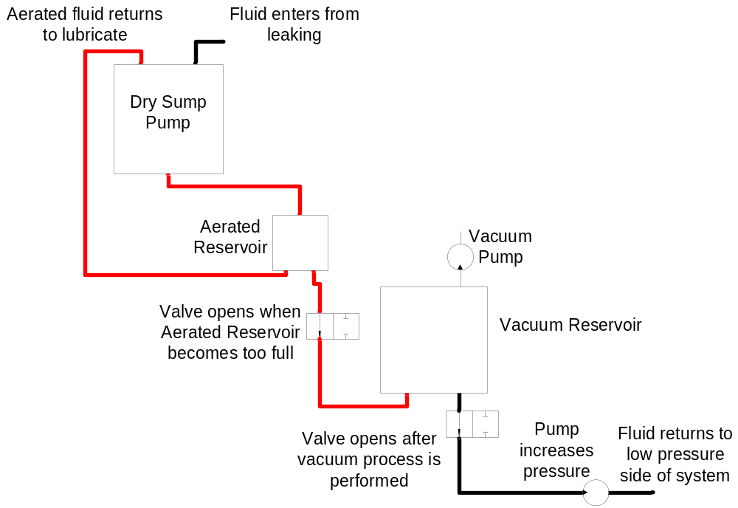
Deaerated oil
Aerated oil

Resources

This Appendix is based on the work of Ian Hanna in summer 2006.
[?] Ping Zheng, Anyuan Chen, Peter Thelin, Waqas Arshad, Chandur Sadarangani. (2007) “Research on a Tubular Longitudinal Flux PM Linear Generator Used for Free-Piston Energy Converter”. Eml symposium Paper #81.
[?] Paul Cook, Peter James, Mark Willows. (2002) “Rapid Prototyping of Generic Hybid Concept Vehicles”. SAE paper 2002-01-0755.
[?] Morteza Montazeri-Gh, Amir Poursamad. (2006) “Application of Genetic Algorithm for Simultaneous Optimixation of HEV Component Sizing and Control Strategy”. Int. J. Alternative Propulsion Vol. 1 No. 1.
[?] F. V. Conte. (2006) “Battery and Battery Management for Hybrid Electric Vehicles: a Review”. E&I 7 September 2006.
[?] Mohammad Elahinia, Walter W. Olson. (2006) “Chassis Vibration Control for Hydraulic Hybrid Vehicles”. SAE paper 2006-01-1970.
[?] R. P. Kepner. (2002) “Hydraulic Power Assist – A Demonstratino of Hydraulic Hybrid Vehicle Regenerative Braking in a Road Vehicle Application”. SAE paper 2002-01-3128.
[?] R. Apter, M.Prathaler. (2002) “Regeneration of Power in Hybrid Vehicles”. IEEE.
[?] Neil Johnson. Personal Interview. 5 April 2007.
[?] Andy Moskalik. Personal Interview. 4 May 2007.
[?] W. D. Phillips. (2006) “The High-Temperature Degradation of Hydraulic Oils and Fluids”. Journal of Synthetic Lubrication #23.
[?] George Deuard Totten, Lauralice de Campos Franceschini Canale, Hong Liang. (2005) “Hydraulic Cavitation from a Sonomaterials Science Perspective: A Review”. SAE paper 2005-01-4173.
[?] P. Hodges. (1996) Hydraulic Fluids. Elsevier.
[?] “Degassing Pump, Degassing Equipment”. Yokota Manufacturing Co. 1 Jun. 2006. <http://www.aquadevice.com/english/00index.htm>
[?] “Bubb-Less”. G.E. Totten & Associates. G.E. Totten & Associates. 1 Jun. 2006. <http://www.getottenassociates.com/products/ bubless.shtml>
[?] Ryushi Suzuki, Yutaka Tanaka, Kazuyoshi Arai, Shinich Yokota. (1998) “Bubble Elimination in Oil for Fluid Power Systems”. SAE paper 982037.
[?] Ryushi Suzuki, Yutaka Tanaka. (2002) “Solution of Air Entrainment for Fluid Power Systems”. SAE paper 2002-01-1387.
[?] H Yamaguchi, D. Matsubara, S. Shuchi. (2001) “Flow Characteristics and Micro-Bubbles Behaviour in a Rotating Pipe Section with an Abrupt Enlargement”. IMechE.
[?] C. Knuppel, K. Brodt, J. Resemann, G. Tan. (2001) “Development of Membrane Based Gas Trap”. SAE paper 2001-01-2294.
[?] “Bubble Eliminator Based on Centrifugal Flow”. Lyndon B. Johnson Space Center, Houston, Texas. <http://www.nasatech.com/Briefs/Aug04/MSC22996.html>
[?] “Degassing module for chemical fluids”. Dainippon Ink and Chemicals. 1 Jun. 2006. <http://www.dic.co.jp/eng/products/memb/pf-f.html>
[?] Stu Nemser. Telephone Interview. “Compact Membrane Systems Specifications”. 31 May 2006.
[?] Stephen F. Yates, Tihomir Tonev, Allen K. MacKnight, Robert J. Kay. (2006) “Modified X Zeolites as Next Generation Carbon Dioxide Adsorbents”. SAE paper 2006-01-2194.
[?] Yang, Ralph. Personal Interview. “Zeolite Oil Applications”. 6 Jun. 2006.
[?] Chris Morgan, Jill Cummings, Roy Fewkes. (2004) “A New Method of Measuring Aeration and Deaeration of Fluids”. SAE paper 2004-01-2914.
[?] Teyssedout, Aube, and Champagne. “Void fraction measurement system for high temperature flows”. 25 Aug. 2006. <http://ej.iop.org/links/r,RTNWz2z/6urx1F-Q2xGSCpjlav5vpA/mt920508.pdf>
[?] Hamad, Imberton, and Bruun. “An optical probe for measurements in liquid-liquid two-phase flow”. 26 Aug. 2006. <http://ej.iop.org/links/rUlLUJ18z/vqiJImGQ2xGozabgav5vpA/e71012.pdf>
[?] “Flow & Level Measurement”. Transactions vol. 4. 15 Aug. 2006. <http://www.omega.com/literature/transactions/volume4/T9904-10-MASS.html>
[?] J. Jalber, R. Gilbert, M.A. El Khakani. (2002) “Comparative Study of Vapor-Liquid Phase Equilibrium Methods to Measure Partitioning Coefficients of Dissolved Gasses in Hydrocarbon Oils”. Vieweg & Sohn Verlagsgesellschaft.
[?] “Bubble Hydrodynamics”. 24 February 2007. <http://www.bubbleology.con/hydrodynamics.html>
[?] Mobile. 3/14/2007 <http://www.mobil.com/USA-English/Lubes/PDS/GLXXENPVLMOMobil_1_Synthetic_ATF.asp>
[?] Roland Bishop. Telephone Interview. 6 Jun. 2006
[?] Seigo Matsuzaki. Telephone Interview. 1 Jun. 2006
[?] “AMSOIL Synthetic Automatic Transmission Fluid for Smooth Shifting”. 2006. PerformanceMotorOil.com. 31 May 2006. <http://www.performancemotoroil.com/transmission_fluid.html >

